**Day -02 class**

**Introduction to Linux Basic Commands**

* **Cal command** show current month calendar on the terminal with the current date highlighted.

* **Cal[month][year]:** shows calendar of selected month and year for example :cal 8 2024 displays the calendar for August 2024 .

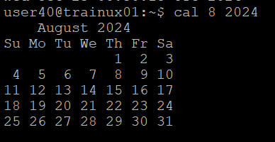

* **Date command** is used to display the system date and time date command is also used to set date and time of the system by default the date command displays the date in the time zone on which Unix or Linux operating system is configured you must be the Super user (root) to change the date and time



* **whoamI command** is a tool that determines the current username of the user logged in



* **Who command** is a tool print information about users who are currently logged in

* **ll command** is used for displaying detailed directory listing.

* **man** command is used to get the manual information of a command in linux/unix system.



* The **uname command** writes to standard output the name of the operating system that you are using.





* **mkdir command** -To create new directories this command is used , to createmore than one directory at once specify the names of the new directories after mkdir with a blank space between them



* **CD command** in Linux is used to change the current working directory here the directory is changed to test zero one.



* **Vi command** -The default editor that comes with the Linux operating system is called VI (visual editor) using vi editor we can edit an existing file or create a new file from scratch we can also use this editor to just read a text file the advanced version of the VDI editor is the Vim editor



* The **pwd command** stands for present working directory displays the full path of the current directory.

* **PS command** in Linux is a command line utility that provides information about the processes running on the Linux system it stands for “process status”.

* **kill command** the kill -9 command sends a SIGKILL signal to a service shutting it down immediately.An unresponsive programme ignores kill command but it shuts down whenever a kill -9 command is issued.
* In above image the vi is running in the background this process is killed by using the kill-9 command as shown below by mentioning it with the process id(PID) so the syntax is :

**Kill -9 [PID]**

now in the below image the process got killed.

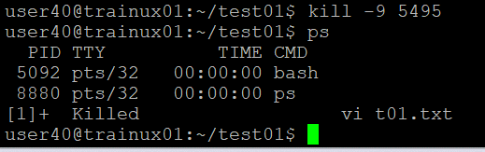

* **which printf** command finds the location of the printed command as /usr /bin/ printf meaning it's accessible in the system PATH.



* **which ls -**This tells that the ls command is located in /bin .



* **locate printf** command lists various printf- related files mostly from the GLib

library source (like gprintf.c,printf-args.h) these files are located in /home/itcharles/glib-2.36.3 and /opt/glib-2.36.3 indicating Glib source or development files on your system

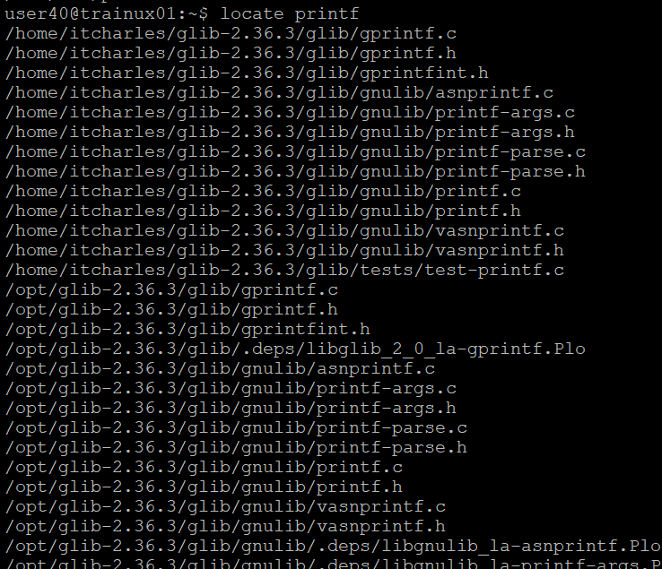

* The inode number of a file can be displayed by using the command :

**ls -i**

